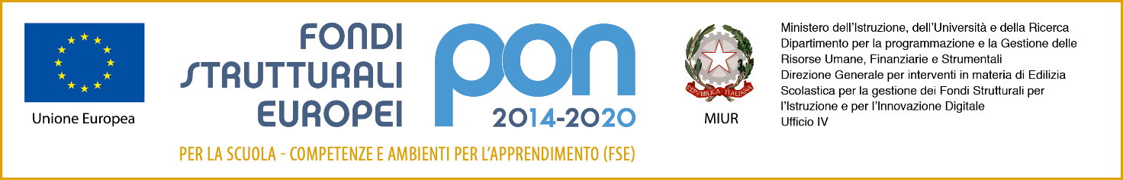
Ministero dell’Istruzione, dell’Università e della Ricerca
ISTITUTO PROFESSIONALE DI STATO “GAETANO PESSINA”
COMO Via Milano, 182
Tel. 031/2765511 -
e-mail: info@istitutopessina.gov.it – http://www.istitutopessina.gov.it
Posta elettronica certificata: CORC010008@pec.istruzione.it

MODULO DI ISCRIZIONE PER LO SPORTELLO DIDATTICO
( ALLEGATO N. 1)

Da compilare da parte dell’alunno:

Nome e cognome __________________________________________________________

Classe _________________________________________________________________

Materia _________________________________________________________________________

Docente scelto _______________________________________________________________

Argomento da trattare ____________________________________________________________________________________________________________________________________________________________________________________________________________________________________________________________________________________________________________________

Luogo e data _______________, ____ / ____ / _____

